INFOSYS INTERNSHIP

**IMPORT REQUIREMENTS**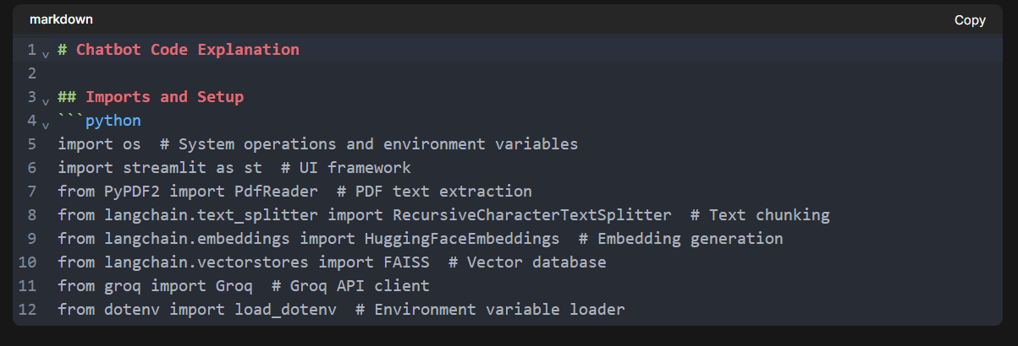

**Environment Configuration**

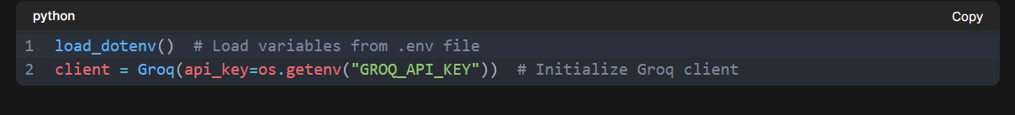

**Streamlit UI Setup**

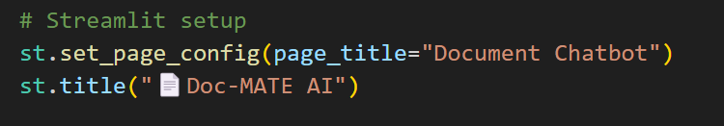

**Session State Management**

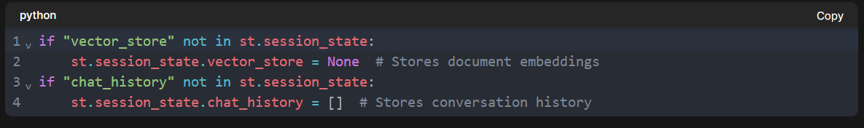

**File Processing Function**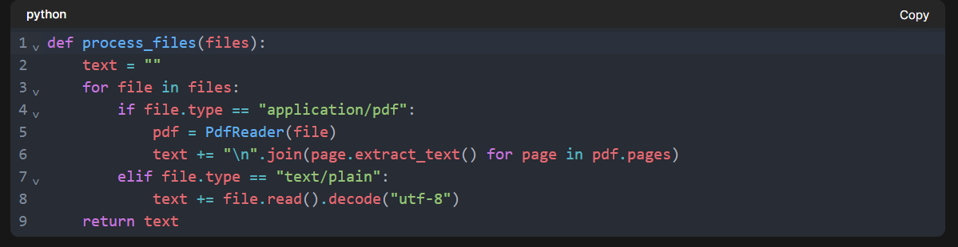

**Purpose** : Extracts text from PDF/TXT files  
**How it works** :

* PDFs: Uses PyPDF2 to extract text from each page
* TXT: Decodes bytes to UTF-8 string
* Combines all text into single string

**Text Splitting Function**

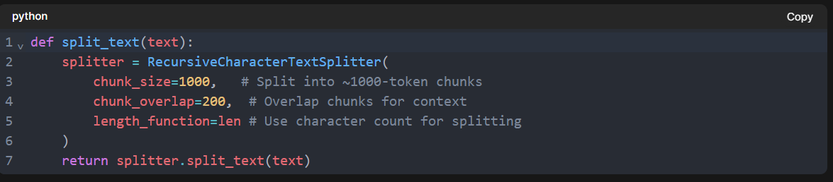

**Vector Store Creation**

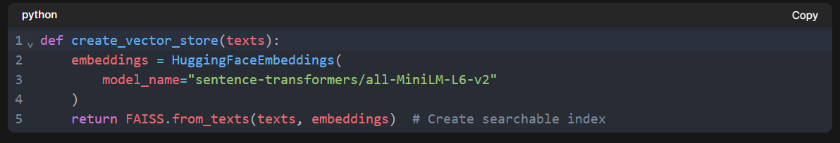

**RAG Pipeline Function**

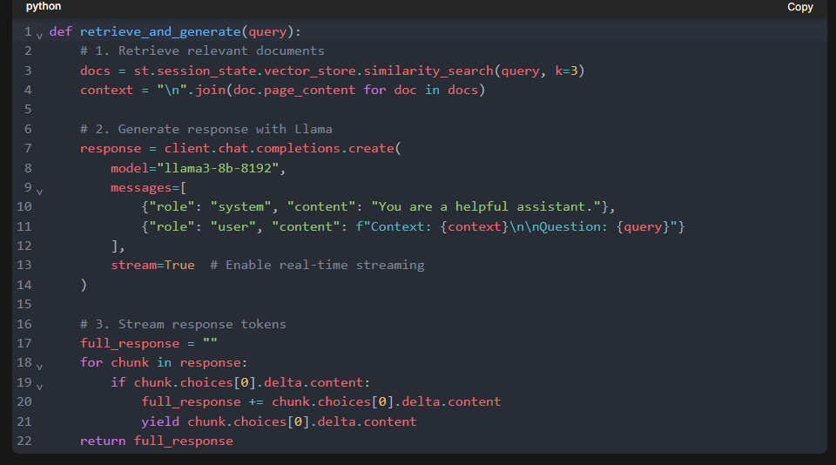

**UI Components (Sidebar)**

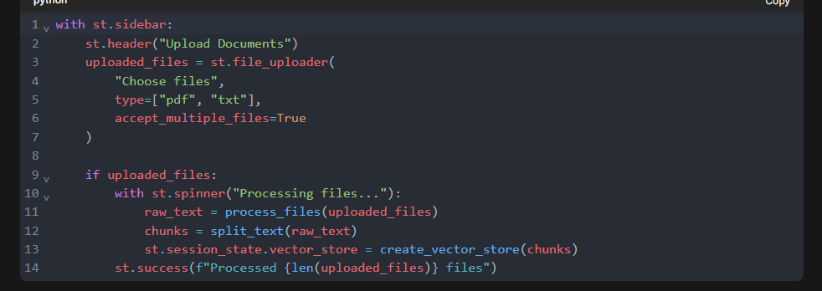

**Chat Interface**

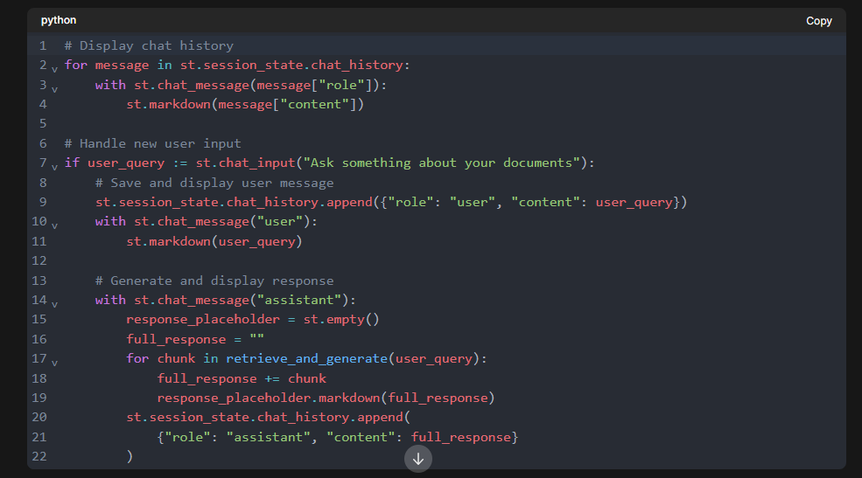

**Key Workflow**

1. **File Upload** : Process documents into text chunks
2. **Embedding** : Convert chunks into numerical vectors
3. **Query Handling** : Retrieve relevant chunks using FAISS
4. **Response Generation** : Stream answers from Llama model
5. **UI Update** : Real-time display of conversation